**YOLO Reproduction-4**

Advisor: Dr. Chih-Yu Wang

Presenter: Shao-Heng Chen

Date: July, 27, 2022

1. YOLOv3 problems

(1) currently still untrainable

(2) original YOLOv3 network architecture

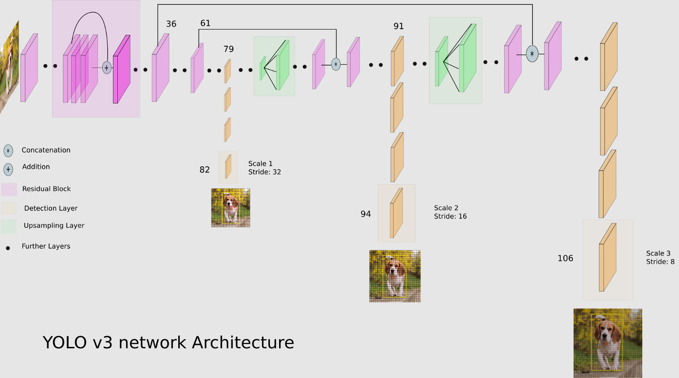

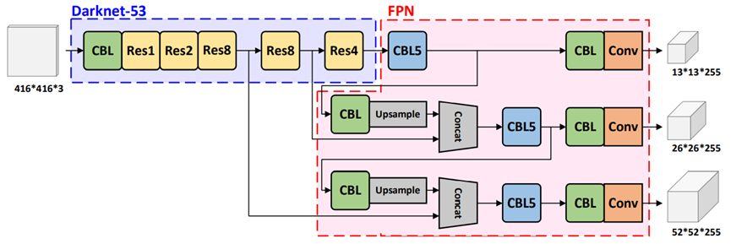

(3) YOLO-CFAR network architecture

- YOLO-CFAR vs. Keras YOLOv3 model comparison (<https://github.com/paulchen2713/YOLO_project/commit/ae46523c274b97774db01dd9af90bc8c48dc174f>)

- YOLOv3-PyTorch model (<https://github.com/paulchen2713/YOLO_project/commit/05fe39a7036da9ff71c32b6f027ab93d8490379b>)

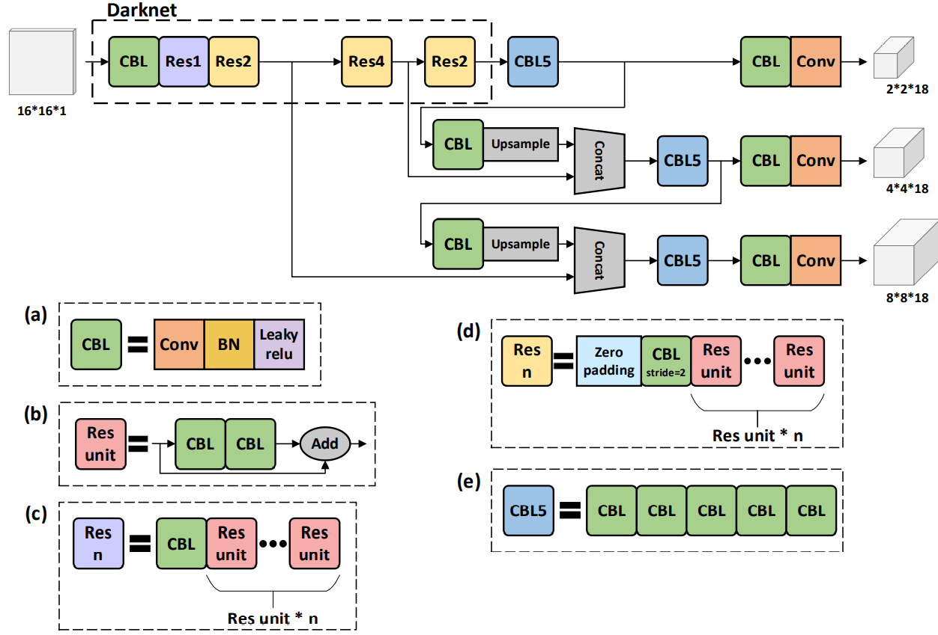

# -*- coding: utf-8 -*-

"""

Created on Mon Jul 18 17:04:43 2022

@author: Paul

@file: model.py

@dependencies:

    env pt3.7

    python 3.7.13

    torch >= 1.7.1

    torchvision >= 0.8.2

@references:

    Redmon, Joseph and Farhadi, Ali, YOLOv3: An Incremental Improvement, April 8, 2018. (https://doi.org/10.48550/arXiv.1804.02767)

    Ayoosh Kathuria, Whats new in YOLO v3?, April, 23, 2018. (https://towardsdatascience.com/yolo-v3-object-detection-53fb7d3bfe6b)

    Sanna Persson, YOLOv3 from Scratch, Mar 21, 2021. (https://sannaperzon.medium.com/yolov3-implementation-with-training-setup-from-scratch-30ecb9751cb0)

Implementation of YOLOv3 architecture

"""

import torch

import torch.nn as nn

"""

Information about architecture config:

    Tuple is structured by (filters, kernel_size, stride)

    Every conv is a same convolution.

    List is structured by "B" indicating a residual block followed by the number of repeats

    "S" is for scale prediction block and computing the yolo loss

    "U" is for upsampling the feature map and concatenating with a previous layer

"""

config = [

    (32, 3, 1),   # (32, 3, 1) is the CBL, CBL = Conv + BN + LeakyReLU

    (64, 3, 2),

    ["B", 1],     # (64, 3, 2) + ["B", 1] is the Res1, Res1 = ZeroPadding + CBL + (CBL + CBL + Add)*1

    (128, 3, 2),

    ["B", 2],     # (128, 3, 2) + ["B", 2] is th Res2, Res2 = ZeroPadding + CBL + (CBL + CBL + Add)*2

    (256, 3, 2),

    ["B", 8],     # (256, 3, 2) + ["B", 8] is th Res8, Res8 = ZeroPadding + CBL + (CBL + CBL + Add)*8

    (512, 3, 2),

    ["B", 8],     # (512, 3, 2) + ["B", 8] is th Res8, Res8 = ZeroPadding + CBL + (CBL + CBL + Add)*8

    (1024, 3, 2),

    ["B", 4],     # (1024, 3, 2) + ["B", 4] is th Res4, Res4 = ZeroPadding + CBL + (CBL + CBL + Add)*4

    # to this point is Darknet-53 which has 52 layers

    # 52 = 1 + (1 + 1*2) + (1 + 2*2) + (1 + 8*2) + (1 + 8*2) + (1 + 4*2) ?

    (512, 1, 1),  #

    (1024, 3, 1), #

    "S",

    (256, 1, 1),

    "U",

    (256, 1, 1),

    (512, 3, 1),

    "S",

    (128, 1, 1),

    "U",

    (128, 1, 1),

    (256, 3, 1),

    "S",

    # 252 = 1 + 3 + (4+7) + (4+7*2) + (4+7*8) + (4+7*8) + (4+7*4) + 19 + 5 + 19 + 5 + 19 ?

]

config = [

    (32 // 2, 3, 1),

    (64 // 2, 3, 2),

    ["B", 1],     # (64, 3, 2) + ["B", 1] is the Res1

    (128, 3, 2),

    ["B", 2],     # (128, 3, 2) + ["B", 2] is th Res2

    # (256, 3, 2),

    # ["B", 8],     # (256, 3, 2) + ["B", 8] is th Res8

    (512, 3, 2),

    ["B", 4],     # (512, 3, 2) + ["B", 8] is th Res8

    (1024 // 2, 3, 2),

    ["B", 1],     # ["B", 4], to this point is Darknet-53, which has 53 layers?

    # 52 = 1 + (1 + 1*2) + (1 + 2*2) + (1 + 8*2) + (1 + 8*2) + (1 + 4*2) ?

    (512 // 2, 1, 1),

    (1024, 3, 1),

    "S",

    (256, 1, 1),

    "U",

    (256 // 2, 1, 1),

    (512 // 2, 3, 1),

    "S",

    (128 // 2, 1, 1), #

    "U",

    (128 // 2, 1, 1),

    (256 // 2, 3, 1),

    "S",

    # 252 = 1 + 3 + (4+7) + (4+7*2) + (4+7*8) + (4+7*8) + (4+7*4) + 19 + 5 + 19 + 5 + 19 ?

]

*class* CNNBlock(*nn*.*Module*):

*def* __init__(*self*, *in_channels*, *out_channels*, *bn_act*=True, \*\**kwargs*):

*super*(CNNBlock, *self*).__init__()

        # if we do use bn activation function in the block, then we do not want to use bias, its unnecessary

        # **kwargs will be the kernal size, the stride and padding as well

*self*.conv = nn.Conv2d(in_channels, out_channels, *bias*=not bn_act, **kwargs)

*self*.bn = nn.BatchNorm2d(out_channels)

*self*.leaky = nn.LeakyReLU(*negative_slope*=0.1) # default negative_slope=0.01

*self*.use_bn_act = bn_act # indicating if the block is going to use a batch norm NN activation function

*def* forward(*self*, *x*):

        # using if-else statement in the forward pass might lose on some performance, negligible?

        # we use bn activation by default, except for scale prediction

        if *self*.use_bn_act:

            return *self*.leaky(*self*.bn(*self*.conv(x))) # bn_act()

        # for scale prediction we don't want to use batch norm LeakyReLU on our output, just normal Conv

        else:

            return *self*.conv(x)

*class* ResidualBlock(*nn*.*Module*):

*def* __init__(*self*, *channels*, *use_residual*=True, *num_repeats*=1):

*super*(ResidualBlock, *self*).__init__()

*self*.layers = nn.ModuleList()

        for _ in range(num_repeats): # repeat for num_repeats

*self*.layers += [

                nn.Sequential(

                    CNNBlock(channels, channels // 2, *kernel_size*=1, *padding*=0), # down samples or reduces the number of filters

                    # CNNBlock(channels // 2, channels, kernel_size=3, padding=1), # then brings it back again

                    CNNBlock(channels // 2, channels, *kernel_size*=3, *padding*=1),

                )

            ]

        # 1. why specify use_residual in a ResidualBlock? is because in some cases we are going to use skip

        # connections, in some cases we just going through the config file and build the ordinary ResidualBlock

        # 2. why we need to store these?

*self*.use_residual = use_residual # indicating using residual

*self*.num_repeats = num_repeats   # number of repeats set to 1 by default

*def* forward(*self*, *x*):

        for layer in *self*.layers:

            x = layer(x) + x if *self*.use_residual else layer(x)

            # if self.use_residual:

            #     # x = x + layer(x)

            #     x = layer(x) + x

            # else:

            #     x = layer(x)

        return x

*class* ScalePrediction(*nn*.*Module*):

*def* __init__(*self*, *in_channels*, *num_classes*):

*super*(ScalePrediction, *self*).__init__()

        # for every single cell grid we have 3 anchor boxes, for every anchor box we have 1 node for each of the classes

        # for each bounding box we have [P(Object), x, y, w, h] and that's 5 values

*self*.pred = nn.Sequential(

            # CNNBlock(in_channels, 2 * in_channels, kernel_size=3, padding=1),

            CNNBlock(in_channels, 2 * in_channels, *kernel_size*=3, *padding*=1),

            CNNBlock(2 * in_channels, 3 * (num_classes + 5), *bn_act*=False, *kernel_size*=1),

        )

*self*.num_classes = num_classes

*def* forward(*self*, *x*):

        # we want to return the prediction of x, then we want to reshape it to the number of examples in our batch

        # split out_channel "3 * (num_classes + 5)" into two different dimensions "3, (num_classes + 5)", instead of

        # having a long vector of bounging boxes, and change the order of the dimensions

        return (

*self*.pred(x)

            .reshape(x.shape[0], 3, *self*.num_classes + 5, x.shape[2], x.shape[3])

            .permute(0, 1, 3, 4, 2)

        )

        # [x.shape[0], 3, x.shape[2], x.shape[3], self.num_classes + 5], e.g. [N, 3, 13, 13, 5+num_classes]

        # for scale one, we have N examples in our batch, each example has 3 anchors, each anchor has 13-by-13 grid

        # and every cell has (5+num_classes) output, output dimension = N x 3 x 13 x 13 x (5+num_classes)

*class* YOLOv3(*nn*.*Module*):

*def* __init__(*self*, *in_channels*=3, *num_classes*=1):

*super*(YOLOv3, *self*).__init__()

*self*.num_classes = num_classes

*self*.in_channels = in_channels

        # we want to create the layers using the config file, and store them in a nn.ModuleList()

*self*.layers = *self*._create_conv_layers() # we immediately call _create_conv_layers() to initialize the layers

*def* forward(*self*, *x*):

        # need to keep track of outputs and route connections

        outputs = []           # we have one output for each scale prediction, should be 3 in total

        route_connections = [] # e.g. after upsampling, we concatenate the channels of skip connections

        for i, layer in enumerate(*self*.layers):

            if isinstance(layer, ScalePrediction): # if it's ScalePrediction

                outputs.append(layer(x)) # we're going to add that layer

                continue # and then continue from where we were previously, not after ScalePrediction

            # calling layer(x) is equivalent to calling layers.__call__(x), and __call__() is actually calling layer.forward(x)

            # which is defined in class layer(nn.Module), but in practice we should use layer(x) rather than layer.forward(x)

            x = layer(x) #

            print(*f*"layer {i}: ", x.shape)

            # skip layers are connected to ["B", 8] based on the paper, original config file

            if isinstance(layer, ResidualBlock) and layer.num_repeats != 1: #

            # if isinstance(layer, ResidualBlock) and layer.num_repeats == 8:

                route_connections.append(x)

            elif isinstance(layer, nn.Upsample): # if we use the Upsample

                # we want to concatenates with the last route connection, with the last one we added

                x = torch.cat([x, route_connections[-1]], *dim*=1) # why concatenate along dimension 1 for the channels

                route_connections.pop() # after concatenation, we remove the last one

        # print(f"outputs: {outputs}")

        return outputs

    # create the layers using the config files

*def* _create_conv_layers(*self*):

        layers = nn.ModuleList()       # keep track of all the layers in a ModuleList, which supports tools like model.eval()

        in_channels = *self*.in_channels # only need to specifies the first in_channels, I suppose

        # go through and parse the config file and construct the model line by line

        for module in config:

            # if it's a tuple (filters, kernel_size, stride), e.g. (32, 3, 1), then it's just a CNNBlock

            if isinstance(module, *tuple*):

                out_channels, kernel_size, stride = module # we want to take out the (filters, kernel_size, stride)

                layers.append(

                    CNNBlock(

                        in_channels,

                        out_channels,

*kernel_size*=kernel_size,

*stride*=stride,

                        # padding=1 if kernel_size == 3 else 0, # if kernel_size == 1 then padding = 0

*padding*=1 if kernel_size == 3 else 0,

                    )

                )

                # the in_channels for the next block is going to be the out_channels of this block

                in_channels = out_channels # update the in_channels of the next layer

            # if it's a List, e.g. ["B", 1], then it's a ResidualBlock

            elif isinstance(module, *list*):

                num_repeats = module[1] # we want to take out the number of repeats, which is going to be module[1]

                # and module[0] should be "B", which indicates that this is a ResidualBlock

                layers.append(ResidualBlock(in_channels, *num_repeats*=num_repeats,))

            # if it's a String, e.g. "S" or "U", then it might be ScalePrediction or Upsampling

            elif isinstance(module, *str*):

                # "S" for ScalePrediction

                if module == "S":

                    layers += [

                        ResidualBlock(in_channels, *use_residual*=False, *num_repeats*=1),

                        CNNBlock(in_channels, in_channels // 2, *kernel_size*=1),

                        ScalePrediction(in_channels // 2, *num_classes*=*self*.num_classes),

                    ]

                    # after ScalePrediction, we want to continue from CNNBlock, since we have scale_factor=2

                    in_channels = in_channels // 2 # we then wnat to divide in_channels by 2

                # "U" for Upsampling

                elif module == "U":

                    layers.append(nn.Upsample(*scale_factor*=2),)

                    in_channels = in_channels * 3 # 3 == 2 + 1, concatenated the channels from previously

        return layers

if __name__ == "__main__":

    # actual parameters

    num_classes = 1 # 20

    # YOLOv1: 448, YOLOv2/YOLOv3: 416 (with multi-scale training)

    IMAGE_SIZE = 16 # multiples of 32 are workable with stride [32, 16, 8]

    # stride = [8, 4, 2]

    stride = [16, 8, 4] # 16

    # stride = [32, 16, 8] # 32

    # simple test settings

    num_examples = 2

    num_channels = 3 # num_anchors

    model = YOLOv3(*num_classes*=num_classes) # initialize a YOLOv3 model as model

    # simple test with random inputs of 2 examples, 3 channels, and IMAGE_SIZE-by-IMAGE_SIZE input

    x = torch.randn((num_examples, num_channels, IMAGE_SIZE, IMAGE_SIZE))

    out = model(x)

    print("Output Shape: ")

    print("[num_examples, num_channels, feature_map, feature_map, num_classes + 5]")

    for i in range(num_channels):

        print(out[i].shape)

    assert out[0].shape == (2, 3, IMAGE_SIZE//stride[0], IMAGE_SIZE//stride[0], num_classes + 5) # [2, 3, 13, 13, num_classes + 5]

    assert out[1].shape == (2, 3, IMAGE_SIZE//stride[1], IMAGE_SIZE//stride[1], num_classes + 5) # [2, 3, 26, 26, num_classes + 5]

    assert out[2].shape == (2, 3, IMAGE_SIZE//stride[2], IMAGE_SIZE//stride[2], num_classes + 5) # [2, 3, 52, 52, num_classes + 5]

    print("Success!")

# layer 0:  torch.Size([2, 16, 16, 16])

# layer 1:  torch.Size([2, 32, 8, 8])

# layer 2:  torch.Size([2, 32, 8, 8])

# layer 3:  torch.Size([2, 128, 4, 4])

# layer 4:  torch.Size([2, 128, 4, 4])

# layer 5:  torch.Size([2, 512, 2, 2])

# layer 6:  torch.Size([2, 512, 2, 2])

# layer 7:  torch.Size([2, 512, 1, 1])

# layer 8:  torch.Size([2, 512, 1, 1])

# layer 9:  torch.Size([2, 256, 1, 1])

# layer 10:  torch.Size([2, 1024, 1, 1])

# layer 11:  torch.Size([2, 1024, 1, 1])

# layer 12:  torch.Size([2, 512, 1, 1])

# layer 14:  torch.Size([2, 256, 1, 1])

# layer 15:  torch.Size([2, 256, 2, 2])

# layer 16:  torch.Size([2, 128, 2, 2])

# layer 17:  torch.Size([2, 256, 2, 2])

# layer 18:  torch.Size([2, 256, 2, 2])

# layer 19:  torch.Size([2, 128, 2, 2])

# layer 21:  torch.Size([2, 64, 2, 2])

# layer 22:  torch.Size([2, 64, 4, 4])

# layer 23:  torch.Size([2, 64, 4, 4])

# layer 24:  torch.Size([2, 128, 4, 4])

# layer 25:  torch.Size([2, 128, 4, 4])

# layer 26:  torch.Size([2, 64, 4, 4])

# Output Shape:

# [num_examples, num_channels, feature_map, feature_map, num_classes + 5]

# torch.Size([2, 3, 1, 1, 6])

# torch.Size([2, 3, 2, 2, 6])

# torch.Size([2, 3, 4, 4, 6])

# Success!

# layer 0:  torch.Size([2, 32, 416, 416])

# layer 1:  torch.Size([2, 64, 208, 208])

# layer 2:  torch.Size([2, 64, 208, 208])

# layer 3:  torch.Size([2, 128, 104, 104])

# layer 4:  torch.Size([2, 128, 104, 104])

# layer 5:  torch.Size([2, 256, 52, 52])

# layer 6:  torch.Size([2, 256, 52, 52])

# layer 7:  torch.Size([2, 512, 26, 26])

# layer 8:  torch.Size([2, 512, 26, 26])

# layer 9:  torch.Size([2, 1024, 13, 13])

# layer 10:  torch.Size([2, 1024, 13, 13])

# layer 11:  torch.Size([2, 512, 13, 13])

# layer 12:  torch.Size([2, 1024, 13, 13])

# layer 13:  torch.Size([2, 1024, 13, 13])

# layer 14:  torch.Size([2, 512, 13, 13])

# layer 16:  torch.Size([2, 256, 13, 13])

# layer 17:  torch.Size([2, 256, 26, 26])

# layer 18:  torch.Size([2, 256, 26, 26])

# layer 19:  torch.Size([2, 512, 26, 26])

# layer 20:  torch.Size([2, 512, 26, 26])

# layer 21:  torch.Size([2, 256, 26, 26])

# layer 23:  torch.Size([2, 128, 26, 26])

# layer 24:  torch.Size([2, 128, 52, 52])

# layer 25:  torch.Size([2, 128, 52, 52])

# layer 26:  torch.Size([2, 256, 52, 52])

# layer 27:  torch.Size([2, 256, 52, 52])

# layer 28:  torch.Size([2, 128, 52, 52])

# Output Shape:

# [num_examples, num_channels, feature_map, feature_map, num_classes + 5]

# torch.Size([2, 3, 13, 13, 6])

# torch.Size([2, 3, 26, 26, 6])

# torch.Size([2, 3, 52, 52, 6])

# Success!